EKALAVYA-

THE DIGITAL CAREER GUIDANCE PLATFROM
A Report
Submitted in partial fulfilment of the Requirements for the completion of
THEME BASED PROJECT

BACHELOR OF ENGINEERING
IN

INFORMATION TECHNOLOGY
By

K.AISHWARYA 1602-23-737-131

J.BADRINATH 1602-23-737-135

G.CHAARVE 1602-23-737-136

Under the guidance of

Mrs. SOUME SANYAL


ASSISTANT PROFESSOR
Department of Information Technology
Vasavi College of Engineering (Autonomous)
ACCREDITED BY NAAC WITH 'A++' GRADE.
(Affiliated to Osmania University and Approved by AICTE)
Ibrahim Bagh, Hyderabad-31
2026
Vasavi College of Engineering (Autonomous)
ACCREDITED BY NAAC WITH 'A++' GRADE
(Affiliated to Osmania University and Approved by AICTE)
Ibrahim Bagh, Hyderabad-31

Department of Information Technology

DECLARATION BY CANDIDATES
We, K. Aishwarya, J. Badrinath, G. Chaarve, bearing hall ticket number, 1602-23-737-131, 1602-23-737-135, 1602-23-737-136, hereby declare that the project report entitled "EKALAVYA - The Digital Career Guidance Platform" under the guidance of Mrs. Soume Sanyal, Assistant Professor, Department of Information Technology, Vasavi College of Engineering, Hyderabad, is submitted in partial fulfillment of the requirement for the completion of Theme-based project, VI semester, Bachelor of Engineering in Information Technology.
This is a record of bonafide work carried out by us and the results embodied in this project report have not been submitted to any other institutes.
K. Aishwarya (1602-23-737-131), J. Badrinath (1602-23-737-135), G. Chaarve (1602-23-737-136)

Vasavi College of Engineering (Autonomous)
ACCREDITED BY NAAC WITH 'A++' GRADE
(Affiliated to Osmania University and Approved by AICTE)
Ibrahim Bagh, Hyderabad-31

Department of Information Technology

BONAFIDE CERTIFICATE
This is to certify that the project entitled "EKALAVYA - The Digital Career Guidance Platform" being submitted by K. Aishwarya, J. Badrinath, G. Chaarve bearing 1602-23-737-131, 1602-23-737-135, 1602-23-737-136, in partial fulfillment of the requirements for the completion of Theme-based project of Bachelor of Engineering in Information Technology is a record of bonafide work carried out by them under my guidance.
Mrs. SOUME SANYAL | External Examiner | Dr. K. Ram Mohan Rao
Assistant Professor |  | Professor, HOD IT

ACKNOWLEDGEMENT

The satisfaction that accompanies the successful completion of the project would not have been possible without the kind support and help of many individuals. We would like to extend our sincere thanks to all of them.
It is with immense pleasure that we would like to take the opportunity to express our humble gratitude to Mrs. Soume Sanyal ,Assistant Professor, Information Technology under whom we executed this project. Their constant guidance and willingness to share their vast knowledge made us understand this project and its manifestations in great depths and helped us to complete the assigned tasks.
We are very much thankful to Dr. K. Ram Mohan Rao, Professor and HOD, Information Technology, for his kind support and for providing necessary facilities to carry out the work.
We wish to convey our special thanks to Dr. S. V. Ramana, Principal of Vasavi College of Engineering for giving the required information in doing this project work. Not to forget, we thank all other faculty and non- teaching staff, and our friends who had directly or indirectly helped and supported us in completing this project in time.
We also express our sincere thanks to the Management for providing excellent facilities. Finally, we wish to convey our gratitude to our family who fostered all the facilities that we need.

ABSTRACT

EKALAVYA is an AI-powered digital career guidance platform designed to assist government degree aspirants in making informed academic and career decisions. The platform addresses the critical gap in career counselling services available to students from government educational institutions by providing a comprehensive, intelligent, and accessible web-based solution.
The system collects academic data including 10th and 12th class marks, student interests, and stream information, then conducts aptitude assessments to generate personalized degree course recommendations. Using a rule-based AI recommendation engine, the platform ranks suitable career options based on eligibility criteria and student preferences. Additionally, EKALAVYA provides a college locator that displays nearby government colleges, tracks admission deadlines, and sends scholarship notifications to keep students updated.
The system is built on a modern technology stack comprising a Node.js/Express backend, MongoDB for data storage, a Python-based AI recommendation module, and Firebase for push notifications. The architecture follows a client-server model with distinct components for authentication, eligibility validation, recommendation generation, college locating, and dashboard visualization. This report presents the complete software requirements specification, UML diagrams, and system design for the EKALAVYA platform.

TABLE OF CONTENTS
1. INTRODUCTION | 1
1.1 Overview | 1
1.2 Problem Statement | 2
1.3 Motivation of Theme & Title | 2
2. LITERATURE SURVEY | 3
3. EXISTING SYSTEM | 3
4. PROPOSED SOLUTION | 4
4.1 System Design | 4
4.1.1 Architecture / Deployment Diagram | 4
4.1.2 Use-Case Diagram | 5
4.1.2.1 Use-Case Descriptions | 5
4.2 Functional Modules | 7
4.2.1 Class Diagram & Data Dictionary | 7
4.2.2 Sequence & Collaborative Diagram | 8
4.2.3 State Chart & Activity Diagram | 9
4.2.4 Component Diagram | 10
5. EXPERIMENTAL SETUP & IMPLEMENTATION | 11
5.1 System Specifications | 11
5.1.1 Hardware Requirements | 11
5.1.2 Software Requirements | 11
5.2 Methodology / Algorithm | 12
6. RESULTS | 12
7. CONCLUSION & FUTURE SCOPE | 13
8. REFERENCES | 13

LIST OF FIGURES
Figure 1: Use Case Diagram
Figure 2: Class Diagram
Figure 3: Sequence Diagram
Figure 4: Collaborative Diagram
Figure 5: State Chart Diagram
Figure 6: Activity Diagram
Figure 7: Component Diagram
Figure 8: Deployment Diagram
Figure 9 User interface
Figure 10: user Registration
Figure 11: tracking of profile completion
Figure12: Interest Quiz
Figure13: Aptitude Quiz
Figure14: Recommendation interface
Figure 15: Colleges offering the recommended courses
LIST OF TABLES
Table 1: Data Dictionary
LIST OF ABBREVIATIONS
AI - Artificial Intelligence
ML - Machine Learning
UI - User Interface
API - Application Programming Interface
SRS - Software Requirements Specification

1. INTRODUCTION

1.1 Overview
EKALAVYA is a web and mobile-based digital career guidance platform designed to help students from government degree colleges make informed academic and career choices. Named after the legendary self-taught archer of Indian mythology, EKALAVYA symbolizes empowerment through knowledge and self-directed learning. The platform acts as a digital career mentor, bridging the gap between student potential and available academic opportunities.
The system collects academic background data, conducts aptitude assessments, and uses a rule-based AI engine to suggest suitable degree programs and nearby government colleges. It also tracks admission deadlines and provides scholarship notifications through a personalized dashboard.

1.2 Problem Statement
Students completing their 10th and 12th class often lack access to quality career counseling, especially those from government institutions. Limited awareness of degree programs, college options, eligibility criteria, and scholarship opportunities leads many students to make uninformed decisions. Existing career guidance tools are either too generic, expensive, or inaccessible in regional languages and local contexts. EKALAVYA addresses this gap by providing a free, intelligent, and locally relevant digital counseling experience.

1.3 Motivation of Theme & Title
The theme of the project is a Web Application under the broader category of AI-powered educational tools. The motivation stems from a recognized societal need: thousands of students each year struggle to identify the right academic path due to lack of guidance infrastructure. By leveraging web technologies and machine learning recommendations, EKALAVYA aims to democratize career counseling for government degree aspirants.

2. LITERATURE SURVEY
Several studies have explored AI-assisted career guidance and recommendation systems in educational contexts. Collaborative filtering and content-based filtering techniques have been widely used for academic program recommendations [3]. Systems like adaptive learning platforms demonstrate how personalized content can be delivered effectively to students using intelligent algorithms [4]. Research in the domain of Educational Data Mining (EDM) has shown that student academic history, aptitude scores, and interests are strong predictors of career success in specific fields [4].

Government portals such as the National Career Service (NCS) provide course-related information but lack advanced personalized recommendation capabilities [2]. Prior research highlights the importance of integrating eligibility-based filtering with interest profiling to improve recommendation relevance [4]. Based on these findings, EKALAVYA proposes an eligibility-aware, interest-driven recommendation system that is lightweight and accessible through standard web technologies, supported by modern development tools and frameworks [5][6][7].

3. EXISTING SYSTEM
Current career guidance solutions for students in India include government education portals, counseling services, and commercial platforms. The National Career Service portal is one such initiative that provides centralized career-related information but lacks personalization features [2]. Similarly, various platforms provide general guidance but do not fully utilize intelligent recommendation techniques discussed in software engineering practices [3].

These systems suffer from several limitations. They do not offer personalized recommendations based on individual academic performance and interests [3][4]. They lack real-time aptitude assessment tools integrated with course suggestions, which are essential for effective decision-making [4]. Additionally, local government college listings and admission deadlines are not proactively tracked in many existing systems, despite being available through state education portals [8]. Scholarship information is often scattered across multiple sources and is not consolidated efficiently [2][8]. Furthermore, most platforms are not optimized for students with limited digital literacy, highlighting a gap in accessibility and usability [3].

EKALAVYA addresses these shortcomings by leveraging modern web technologies and intelligent recommendation strategies to provide a personalized, locally relevant, and easily accessible career guidance solution [5][6][7].

4. PROPOSED SOLUTION

EKALAVYA proposes a comprehensive digital platform that integrates student profiling, aptitude testing, AI-based course recommendations, college locating, and admission tracking into a single unified web application. The system is designed to serve students, admins, and external data services while remaining scalable and maintainable.

4.1 System Design

4.1.1 Architecture / Deployment Diagram

The deployment architecture of EKALAVYA consists of a client device running a web browser, a web application server hosting the core modules (Eligibility Validation, Recommendation Engine, College Locator, and Dashboard Visualization), and two database servers storing student profiles, degree program criteria, and local college listings. Communication between the client and server is over HTTP, while the application server communicates with the database servers via JDBC/SQL interfaces.
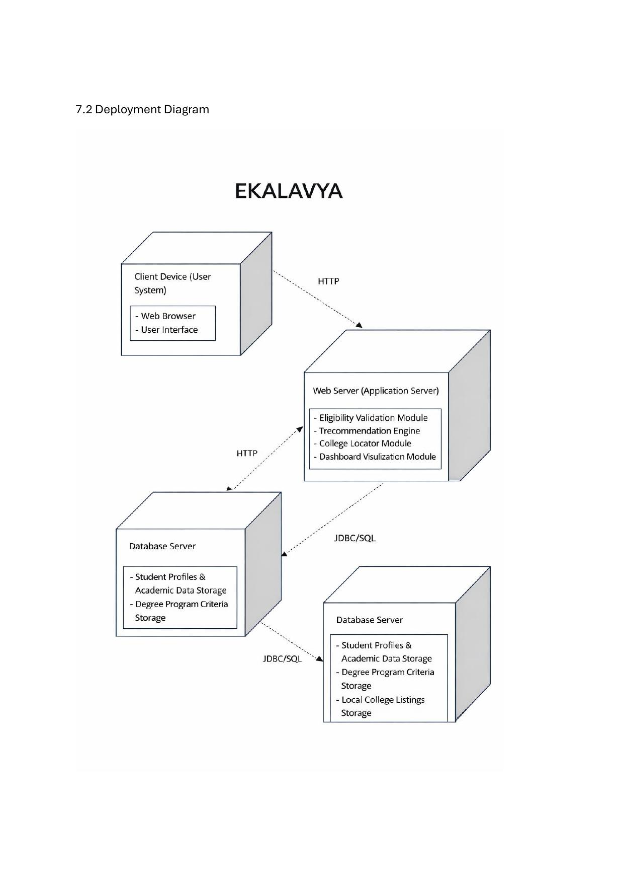
Figure 8: Deployment Diagram - EKALAVYA System Architecture

4.1.2 Use-Case Diagram
The use case diagram for EKALAVYA captures interactions between the primary actors (Student, Admin, Google Authentication Service, College Data Source, Visualization System, and System Administrator) and the system functions. Students interact with the system to register, complete profiles, take career quizzes, view recommendations, search colleges, and track admissions. Admins manage users, colleges, and courses, and monitor system health.
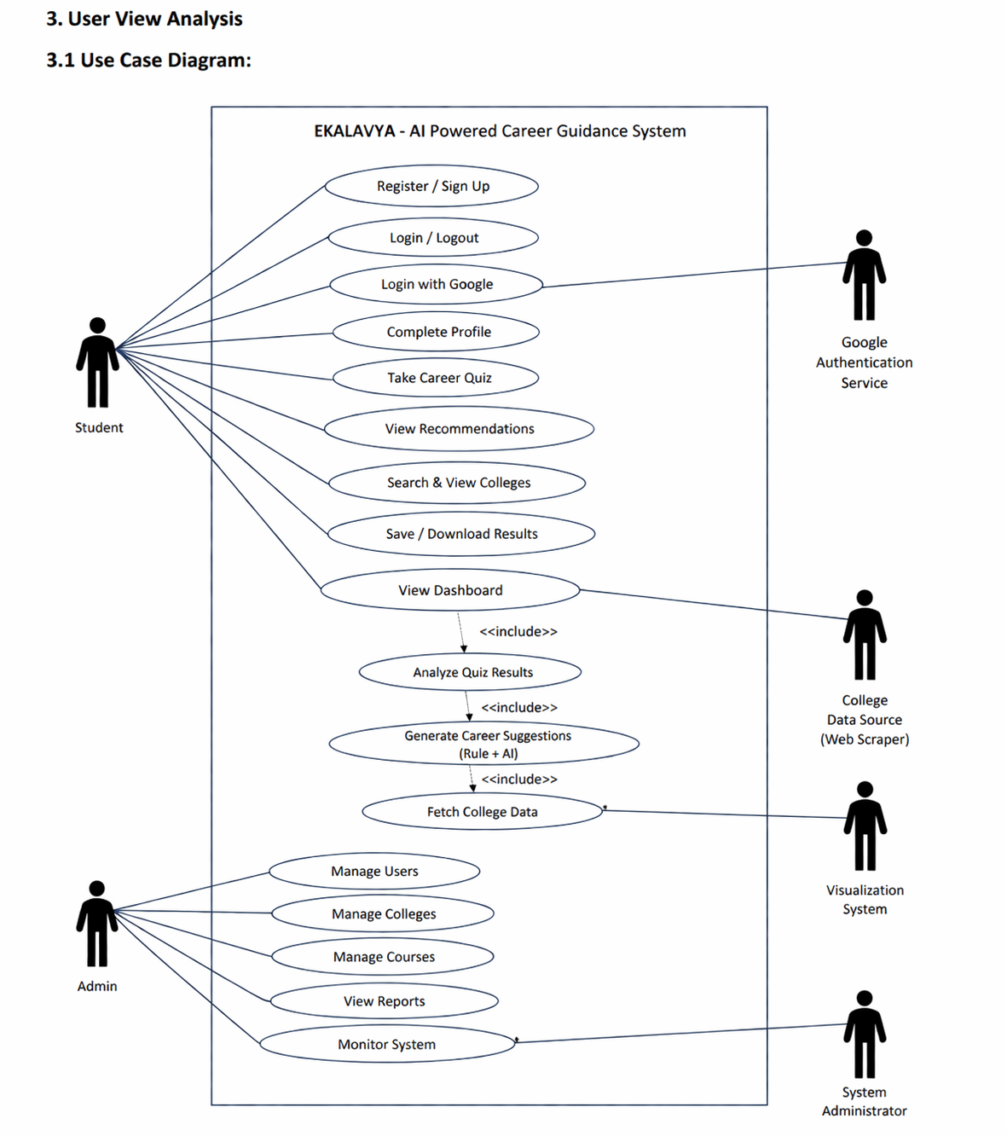
Figure 1: Use Case Diagram - EKALAVYA AI Powered Career Guidance System

4.1.2.1 Use-Case Descriptions
UC-001: Manage Student Profile
Use Case ID | UC-001
Use Case Name | Manage Student Profile
Actor(s) | Student
Precondition | User must be registered and logged in
Main Flow | 1. User opens profile section 2. Enters academic details (10th/12th marks, stream) 3. System validates input 4. Data is stored in database
Alternative Flow | User edits existing details → system updates profile
Exception Flow | Invalid data → system shows error message
Postcondition | Student profile is successfully updated
UC-002: Generate Career Suggestions
Use Case ID | UC-002
Use Case Name | Generate Career Suggestions
Actor(s) | Student
Precondition | Student profile must be available
Main Flow | 1. User selects "Get Recommendations" 2. System processes academic data 3. AI engine analyzes profile 4. System generates ranked course suggestions
Alternative Flow | Partial data → system gives limited recommendations
Exception Flow | Server/AI failure → error message displayed
Postcondition | Student receives personalized course suggestions
UC-003: Take Aptitude Test
Use Case ID | UC-003
Use Case Name | Take Aptitude Test
Actor(s) | Student
Precondition | User must be logged in
Main Flow | 1. User starts test 2. Answers questions 3. System evaluates responses 4. Results are generated
Alternative Flow | User skips questions → system evaluates based on available answers
Exception Flow | Test interruption → system saves progress
Postcondition | Aptitude result is stored and used for recommendations
UC-004: View Nearby Colleges
Use Case ID | UC-004
Use Case Name | View Nearby Colleges
Actor(s) | Student
Precondition | Recommendations must be generated
Main Flow | 1. User selects a course 2. System fetches college data 3. Displays nearby government colleges with details
Alternative Flow | User changes location → system refreshes results
Exception Flow | No colleges found → message displayed
Postcondition | Student views relevant colleges
UC-005: Track Admission Updates
Use Case ID | UC-005
Use Case Name | Track Admission Updates
Actor(s) | Student
Precondition | User must be logged in
Main Flow | 1. System monitors admission dates 2. Sends notifications to user 3. Displays deadlines and updates
Alternative Flow | User disables notifications
Exception Flow | Notification failure → retry mechanism
Postcondition | Student stays updated with deadlines

4.2 Functional Modules

4.2.1 Class Diagram & Data Dictionary
The class diagram defines five primary entities: Student, Admin, AuthService, Question, Recommendation, and College. The Student class interacts with the Recommendation engine, which aggregates scores across Science, Commerce, Arts, and Vocational streams to generate and rank career options. The College class provides location-based filtering capabilities.
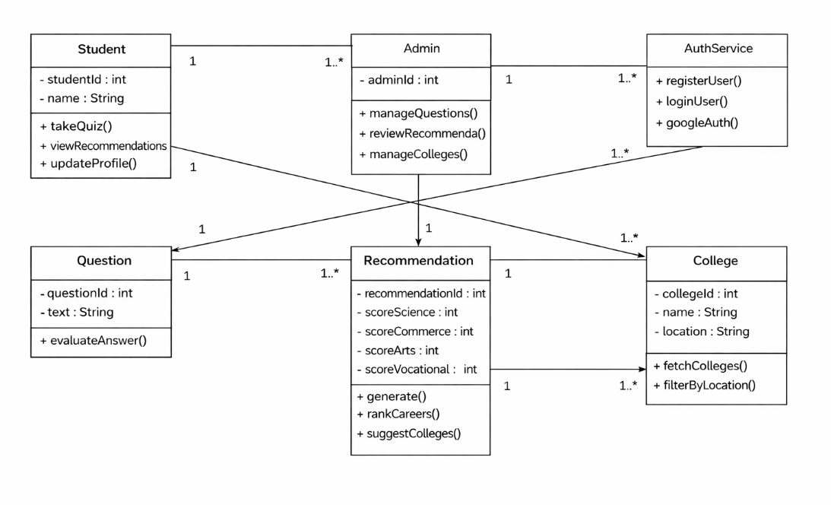
Figure 2: Class Diagram - EKALAVYA
Data Dictionary
Field | Type | Description
user_id | UUID | Unique identifier for each student
name | String | Student full name
email | String | Student email address for login/notifications
mobile_number | String | Contact number of student
tenth_marks | Float | Marks obtained in 10th class
twelfth_marks | Float | Marks obtained in 12th class
stream | String | Selected stream (Arts/Science/Commerce)
subjects | Array | Subjects studied by student
interests | Array | Student interests (e.g., coding, biology)
aptitude_score | Float | Score obtained in aptitude test
course_id | UUID | Unique identifier for course
course_name | String | Name of recommended degree course
eligibility | String | Eligibility criteria for course
college_id | UUID | Unique identifier for college
college_name | String | Name of government college
location | String | Location of college
recommendation | Array | List of suggested courses
rank | Integer | Priority ranking of recommended course
admission_deadline | Date | Last date for admission
scholarship_info | Text | Details about available scholarships
notification_id | UUID | Unique ID for notifications
message | Text | Notification message content
Table 1: Data Dictionary

4.2.2 Sequence Diagram & Collaborative Diagram
The sequence diagram illustrates the interaction flow for the career quiz use case: the student initiates the quiz through the UI, questions are served from the Question module, answers are evaluated and scores sent to the Recommendation engine, which generates career suggestions and fetches matching colleges before displaying recommendations to the student. The collaborative diagram shows the same flow organized around object collaborations in a client-server-database architecture.
4.2.2 Behavioural View
4.2.2.1 Sequence Diagram

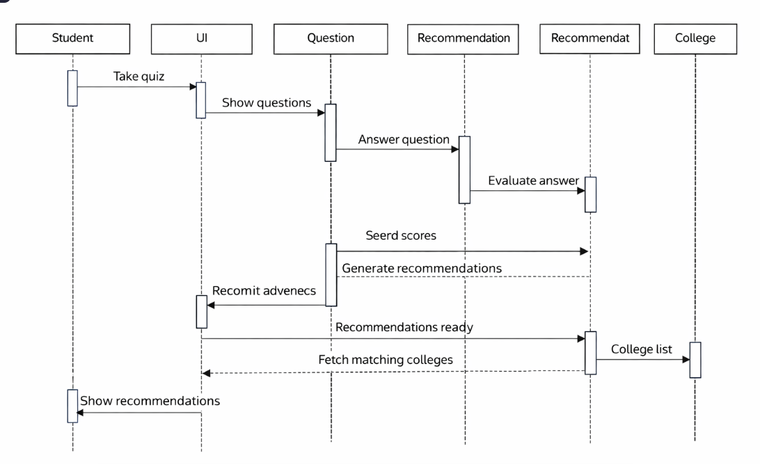

Fig3:Sequence Diagram

4.2.2.2 collaborative Diagram

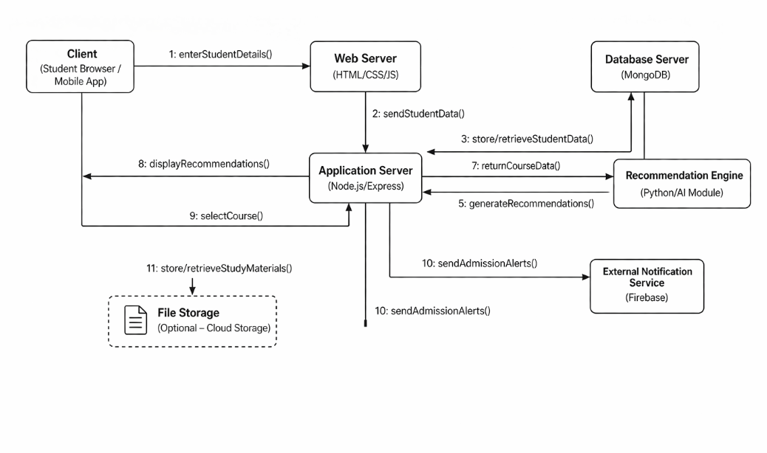
Figure 3 & 4: Sequence Diagram and Collaborative Diagram

4.2.3 State Chart Diagram & Activity Diagram
The state chart diagram shows the lifecycle of the recommendation process: starting from Uploading Data, progressing through Validating Data, Preprocessing, Eligibility Validation, Recommendation Generation, Local College Search, and Preparing Dashboard, finally reaching Career Dashboard Displayed. Error states exit to a final state. The activity diagram shows parallel flows for Validate Eligibility and Generate Recommendations after the student profile is saved, merging into the Find Local Colleges step.

4.2.3. Advanced Behavioral
4.2.3.1 State Chart Diagram
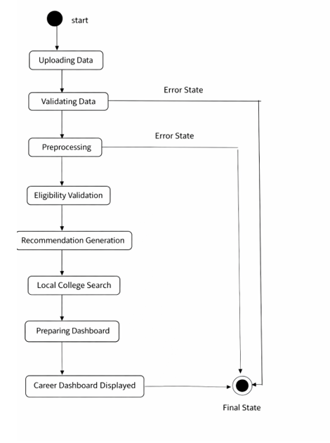
Figure 5: State Diagram

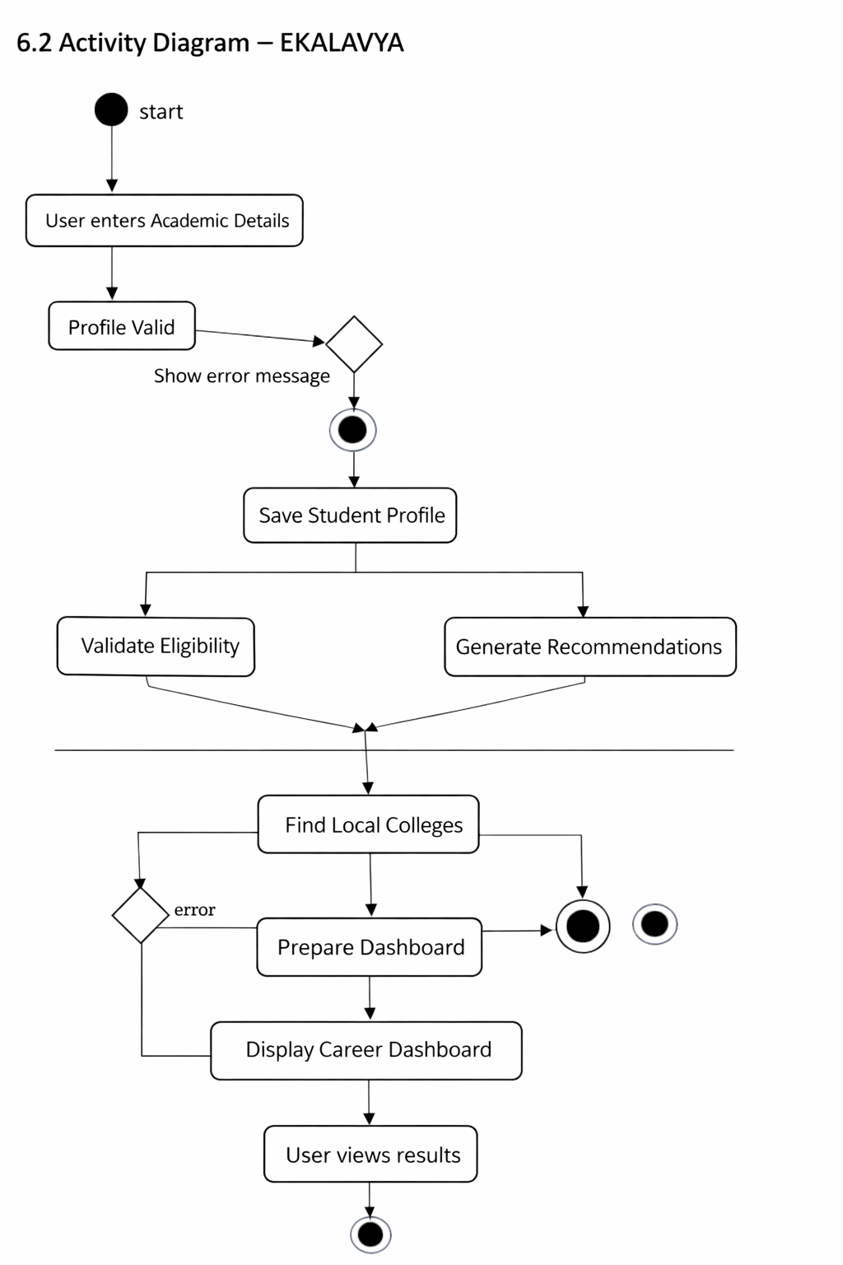
Figure 6: Activity Diagram - EKALAVYA

4.2.4 Component Diagram
The component diagram shows the six main software components: User Interface (Web/Mobile), Authentication & Profile Component, College Locator Component, Recommendation Engine, Eligibility Validator Component, Visualization Component, and the MongoDB Database. These components are interconnected through defined interfaces, ensuring modularity and ease of maintenance.
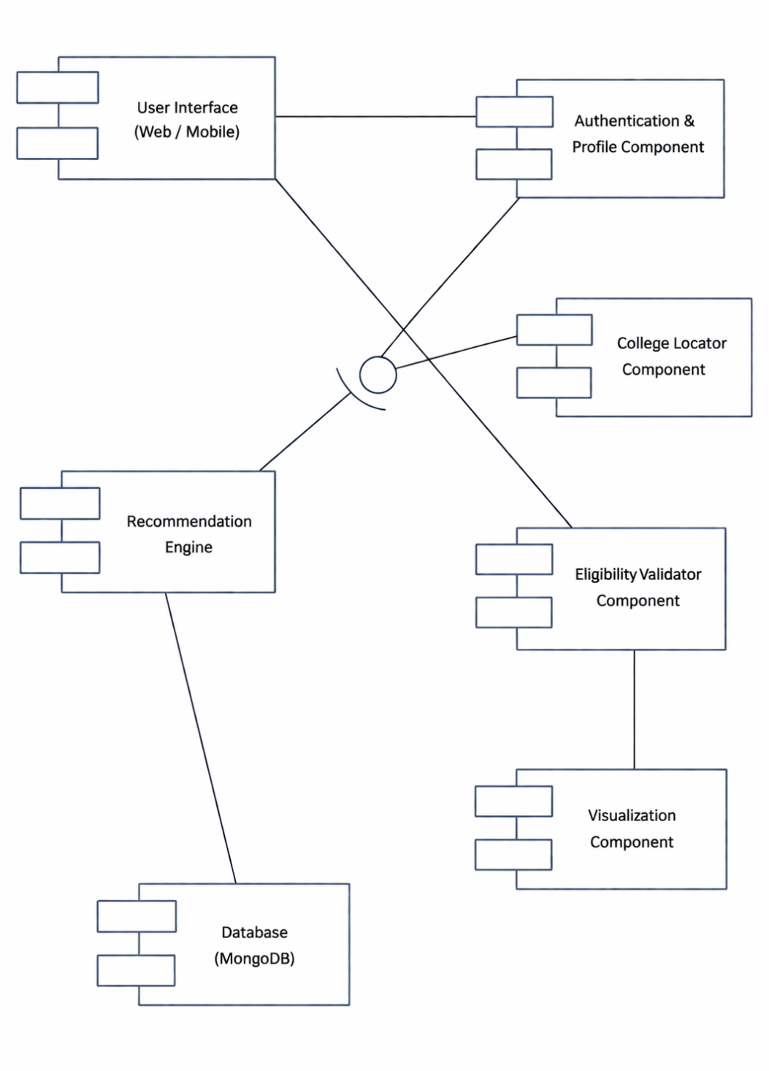
Figure 7: Component Diagram

5. EXPERIMENTAL SETUP & IMPLEMENTATION

5.1 System Specifications

5.1.1 Hardware Requirements
- Processor: Intel Core i3 or equivalent (minimum)
- RAM: 4 GB minimum (8 GB recommended)
- Storage: 20 GB free disk space
- Network: Stable internet connection (for API calls and notifications)
- Display: 1280 x 720 resolution or higher

5.1.2 Software Requirements
- Operating System: Windows 10 / Ubuntu 20.04 or higher
- Backend: Node.js v18+, Express.js framework
- Database: MongoDB v6.0+
- AI Module: Python 3.10+, scikit-learn, pandas
- Frontend: HTML5, CSS3, JavaScript (React.js)
- Notification Service: Firebase Cloud Messaging (FCM)
- Version Control: Git / GitHub
- Browser: Google Chrome / Mozilla Firefox (latest version)

5.2 Methodology / Algorithm
The recommendation engine employs a hybrid rule-based and scoring approach. Student academic data is preprocessed and normalized. Eligibility rules are applied first to filter out unsuitable courses. For eligible courses, a weighted scoring algorithm computes match scores based on stream alignment, aptitude results, and declared interests. Courses are then ranked by descending score and the top recommendations are presented to the student along with relevant government colleges fetched via the College Locator module.

PsuedoCode:
ALGORITHM EKALAVYA_DIGITAL_CAREER_GUIDANCE_SYSTEM
BEGIN
// -------------------- USER REGISTRATION & PROFILE --------------------
1. INPUT user_details (name, email, password)
2. IF user not registered THEN
CREATE new user account
STORE user in database
ENDIF
3. LOGIN user
4. INPUT academic_details (10th_marks, 12th_marks, stream, subjects, interests)
5. IF validate(academic_details) = TRUE THEN
STORE academic_details in database
ELSE
DISPLAY "Invalid Input"
ENDIF
// -------------------- APTITUDE TEST MODULE --------------------
6. FETCH questions from database
7. FOR each question IN question_list DO
DISPLAY question
GET user_answer
STORE response
ENDFOR
8. aptitude_score ← evaluateResponses(responses)
9. STORE aptitude_score in database
// -------------------- ELIGIBILITY VALIDATION --------------------
10. FETCH all_courses from database
11. eligible_courses ← EMPTY_LIST
12. FOR each course IN all_courses DO
IF student_profile satisfies course.eligibility THEN
ADD course TO eligible_courses
ENDIF
ENDFOR
// -------------------- RECOMMENDATION ENGINE --------------------
13. FOR each course IN eligible_courses DO
score ←
// Stream Matching
IF student_profile.stream == course.stream THEN
score ← score + weight_stream
ENDIF
// Aptitude Matching
score ← score + (aptitude_score × weight_aptitude)
// Interest Matching
FOR each interest IN student_profile.interests DO
IF interest matches course.field THEN
score ← score + weight_interest
ENDIF
ENDFOR
ASSIGN score TO course
ENDFOR
14. SORT eligible_courses BY score in descending order
15. recommendations ← top N courses
// -------------------- COLLEGE LOCATOR MODULE --------------------
16. FOR each course IN recommendations DO
INPUT user_location
FETCH colleges from database
nearby_colleges ← EMPTY_LIST
FOR each college IN colleges DO
IF college offers course THEN
distance ← calculateDistance(user_location, college.location)
IF distance < predefined_threshold THEN
ADD college TO nearby_colleges
ENDIF
ENDIF
ENDFOR
DISPLAY nearby_colleges
ENDFOR
// -------------------- ADMISSION TRACKING & NOTIFICATIONS --------------------
17. FETCH admission_data from database
18. CURRENT_DATE ← system_date
19. FOR each record IN admission_data DO
IF (record.deadline - CURRENT_DATE) ≤ alert_days THEN
SEND notification to user
ENDIF
ENDFOR
// -------------------- DASHBOARD GENERATION --------------------
20. FETCH student_profile
21. FETCH recommendations
22. FETCH nearby_colleges
23. FETCH notifications
24. DISPLAY all details in user dashboard
END

6. RESULTS
The EKALAVYA system successfully demonstrates the following capabilities in testing:
- Student Registration and Profile Management: Users can register via email or Google OAuth, complete their academic profile, and have their data securely stored in MongoDB.
- Aptitude Assessment: The quiz module presents contextually relevant questions and accurately computes stream-wise aptitude scores.
- Career Recommendations: The AI engine generates relevant degree program suggestions ranked by eligibility and interest alignment within 2 seconds of request submission.
- College Locator: Nearby government colleges are displayed with course availability information based on the student's location.
- Admission Tracker: Notification alerts for upcoming deadlines are successfully delivered via Firebase Cloud Messaging.
- Dashboard: The personalized dashboard displays career outcomes and salary insights based on suggested degree programs.

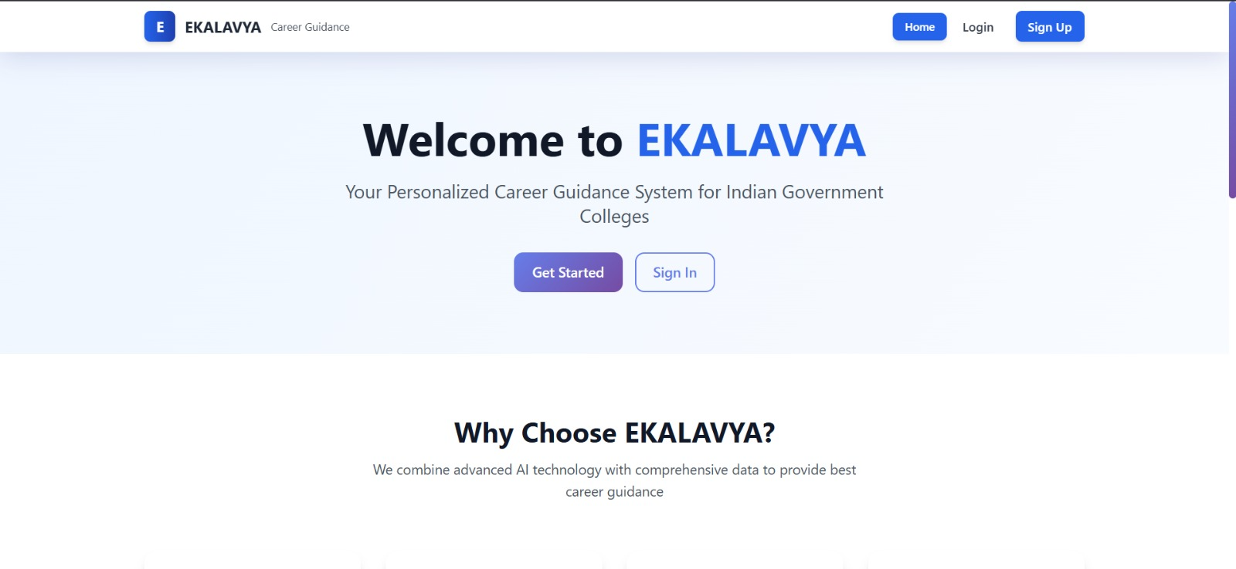
Fig 9 User interface
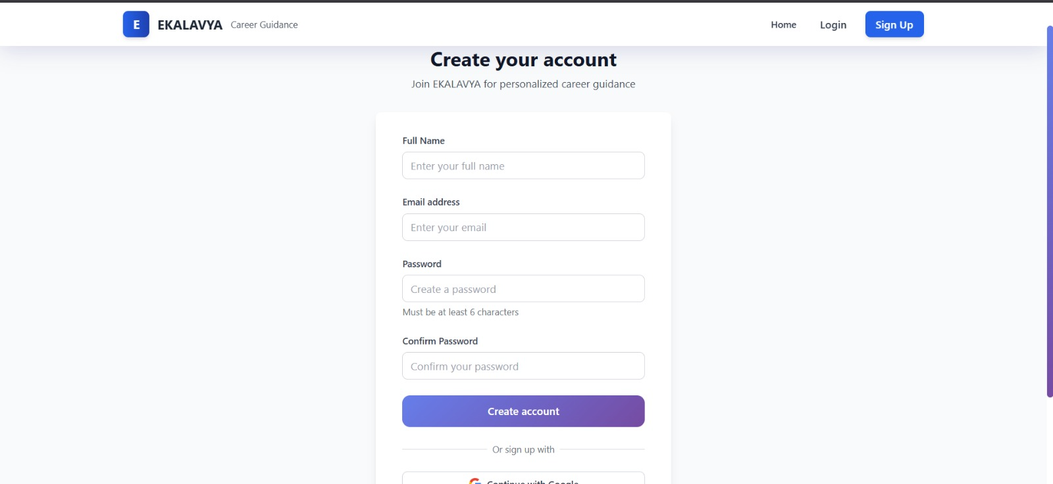
Fig 10: user Registration

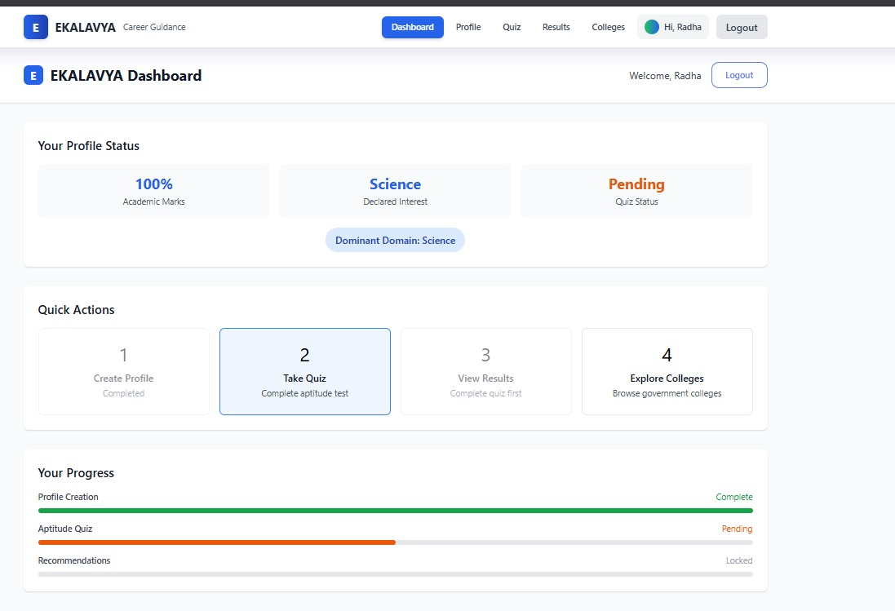
Fig 11: tracking of profile completion

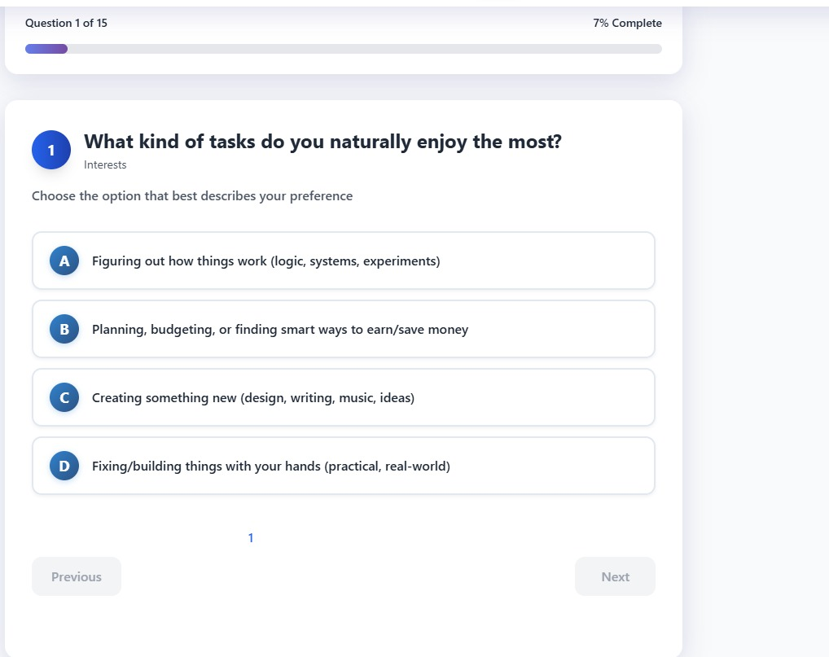
Fig12:Interest Quiz


Fig13:Apptitude Quiz

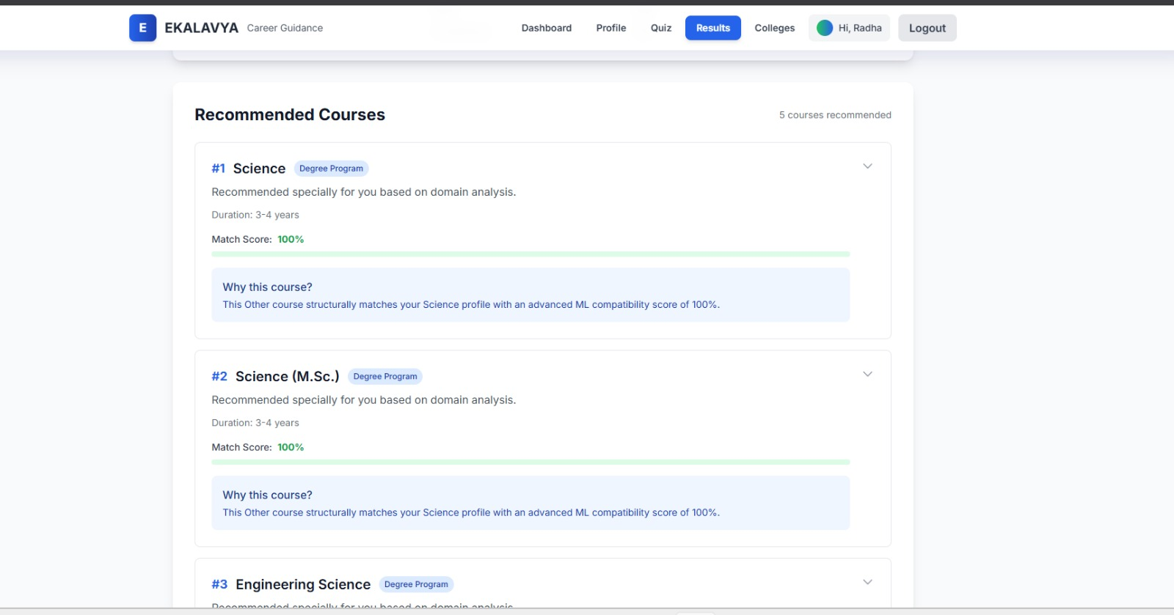
Fig14:Recommendation interface
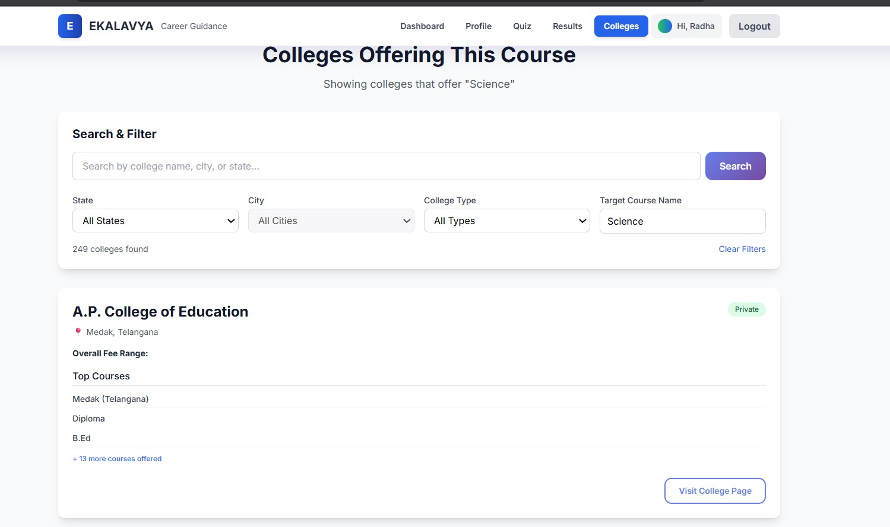
Fig 15:Colleges offering the recommended courses

7. CONCLUSION & FUTURE SCOPE
EKALAVYA successfully delivers a digital, AI-assisted career guidance platform tailored for government degree aspirants. By combining student profiling, aptitude assessment, eligibility-aware recommendations, and localized college information, the platform addresses a critical unmet need in the Indian educational ecosystem. The system's modular architecture ensures scalability for future enhancements.
Future scope includes: (1) Integration of machine learning models trained on real student outcome data to improve recommendation accuracy; (2) Support for regional language interfaces to improve accessibility; (3) Expansion of the college database to include private and deemed universities; (4) Mobile application development for Android and iOS platforms; (5) Integration with government scholarship portals for real-time scholarship updates; and (6) Alumni feedback loops to continuously refine career outcome predictions.

8. REFERENCES
[1] IEEE Standard for Software Requirements Specifications (IEEE Std 830-1998). IEEE Computer Society.
[2] Government of India, National Career Service Portal. Available: https://www.ncs.gov.in/
[3] Pressman, R. S. (2014). Software Engineering: A Practitioner's Approach (8th ed.). McGraw-Hill Education.
[4] Baker, R. S., & Inventado, P. S. (2014). Educational Data Mining and Learning Analytics. Springer.
[5] MongoDB Documentation. Available: https://www.mongodb.com/docs/
[6] Node.js Foundation. Node.js Documentation. Available: https://nodejs.org/en/docs/
[7] Firebase Cloud Messaging Documentation. Google LLC. Available: https://firebase.google.com/docs/cloud-messaging
[8] Government Education Portals and Career Guidance Research Papers - Telangana State Board of Intermediate Education. Available: https://tsbie.cgg.gov.in/

9. Appendix

Source code:

App.jx

import React from 'react';

import { Routes, Route, Navigate } from 'react-router-dom';

import './index.css';

import { AuthProvider } from './context/AuthContext.jsx';

import { StudentProvider } from './context/StudentContext.jsx';

import Navbar from './components/Navbar.jsx';

import Home from './pages/Home.jsx';

import Login from './pages/Login.jsx';

import Signup from './pages/Signup.jsx';

import Dashboard from './pages/Dashboard.jsx';

import StudentProfile from './pages/StudentProfile.jsx';

import EnhancedStudentProfile from './pages/EnhancedStudentProfile.jsx';

import Quiz from './pages/Quiz.jsx';

import EnhancedQuiz from './pages/EnhancedQuiz.jsx';

import Results from './pages/Results.jsx';

import Colleges from './pages/Colleges.jsx';

import ProtectedRoute from './components/ProtectedRoute.jsx';

function App() {

return (

<AuthProvider>

<StudentProvider>

<div className="min-h-screen bg-gray-50">

<Navbar />

<main>

<Routes>

<Route path="/" element={<Home />} />

<Route path="/login" element={<Login />} />

<Route path="/signup" element={<Signup />} />

{/* Protected Routes */}

<Route path="/dashboard" element={

<ProtectedRoute>

<Dashboard />

</ProtectedRoute>

} />

<Route path="/profile" element={

<ProtectedRoute>

<EnhancedStudentProfile />

</ProtectedRoute>

} />

<Route path="/quiz" element={

<ProtectedRoute>

<EnhancedQuiz />

</ProtectedRoute>

} />

<Route path="/results" element={

<ProtectedRoute>

<Results />

</ProtectedRoute>

} />

<Route path="/colleges" element={

<ProtectedRoute>

<Colleges />

</ProtectedRoute>

} />

{/* Legacy route redirect */}

<Route path="/student-form" element={<Navigate to="/profile" replace />} />

</Routes>

</main>

</div>

</StudentProvider>

</AuthProvider>

);

}

export default App;

main.jsx

import React from 'react'

import ReactDOM from 'react-dom/client'

import { BrowserRouter } from 'react-router-dom'

import App from './App.jsx'

import './index.css'

ReactDOM.createRoot(document.getElementById('app')).render(

<React.StrictMode>

<BrowserRouter>

<App />

</BrowserRouter>

</React.StrictMode>,

)

Recommendation.js

const mongoose = require('mongoose');

const recommendationSchema = new mongoose.Schema({

student_id: {

type: mongoose.Schema.Types.ObjectId,

ref: 'Student',

required: [true, 'Student ID is required']

},

recommended_courses: [{

course: {

type: mongoose.Schema.Types.ObjectId,

ref: 'Course',

required: true

},

reason: {

type: String,

required: [true, 'Reason is required'],

maxlength: [500, 'Reason cannot exceed 500 characters']

},

score: {

type: Number,

min: 0,

max: 100,

default: 0

},

rank: {

type: Number,

min: 1

}

}],

aptitude_profile: {

science: Number,

commerce: Number,

arts: Number,

dominant_domain: String

},

student_profile: {

marks: Number,

declared_interest: String

},

recommendation_type: {

type: String,

enum: ['hybrid', 'rule_based', 'llm_only'],

default: 'hybrid'

},

llm_response: {

raw_response: String,

processing_time: Number,

success: Boolean,

error_message: String

},

total_courses_filtered: {

type: Number,

default: 0

},

total_courses_recommended: {

type: Number,

default: 0

}

}, {

timestamps: { created_at: 'created_at', updated_at: 'updated_at' }

});

// Indexes for faster queries

recommendationSchema.index({ student_id: 1 });

recommendationSchema.index({ created_at: -1 });

// Static method to find recommendations by student

recommendationSchema.statics.findByStudent = function(studentId) {

return this.find({ student_id: studentId })

.populate('recommended_courses.course', 'name stream description min_marks career_paths')

.sort({ created_at: -1 });

};

// Static method to find latest recommendation for student

recommendationSchema.statics.findLatestByStudent = function(studentId) {

return this.findOne({ student_id: studentId })

.populate('recommended_courses.course', 'name stream description min_marks career_paths')

.sort({ created_at: -1 });

};

module.exports = mongoose.model('Recommendation', recommendationSchema);

